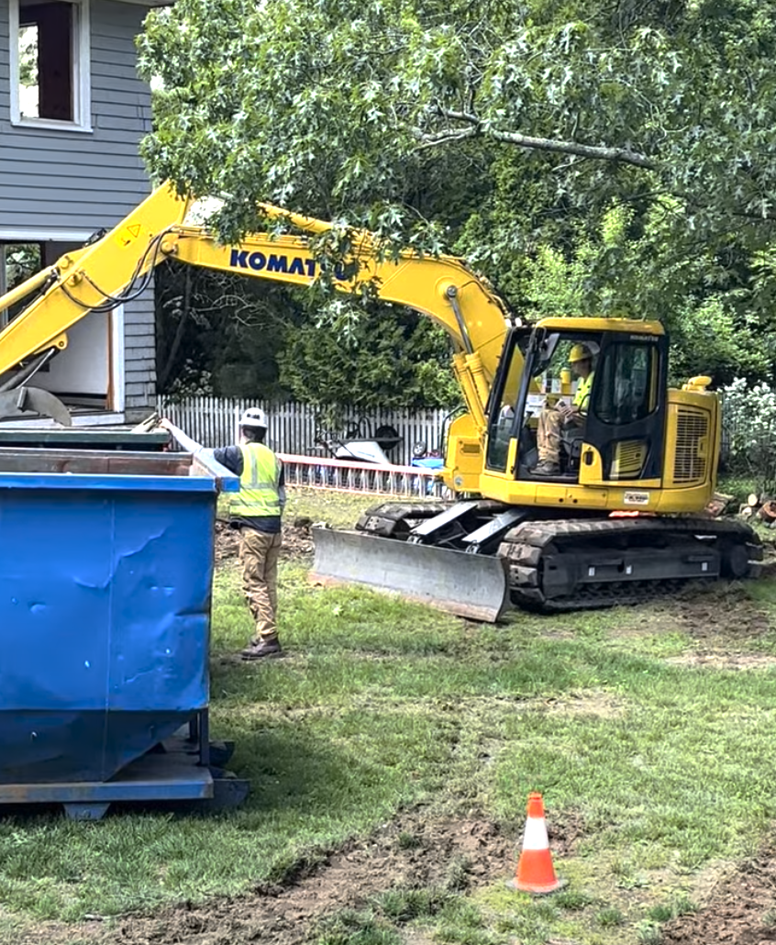
Figure 1: My 19-year-old son practicing with an excavator that I own
on a property that I own under my direct supervision.

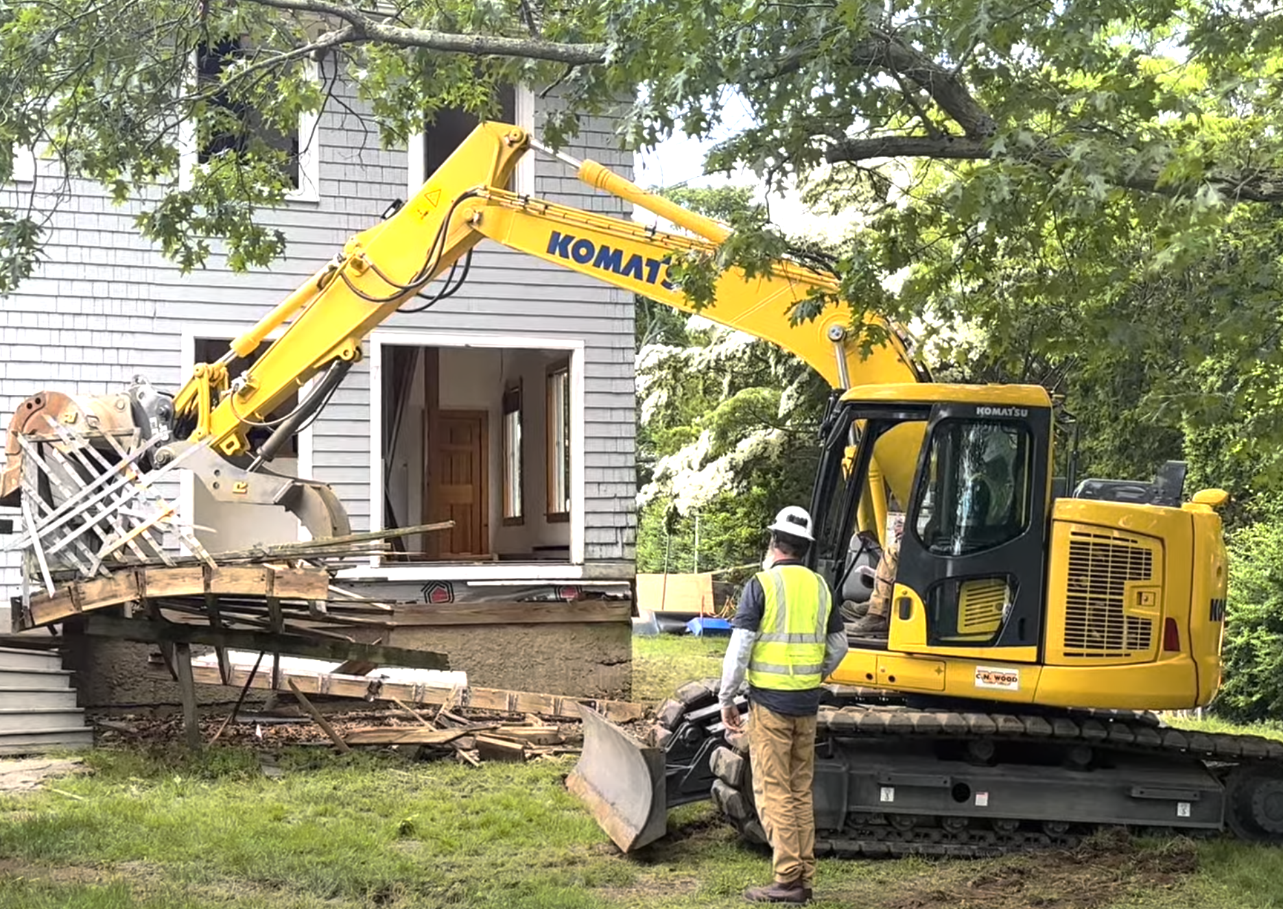
Figure 2: My son’s time at the controls was brief and limited in scope to pulling a deck off the house.
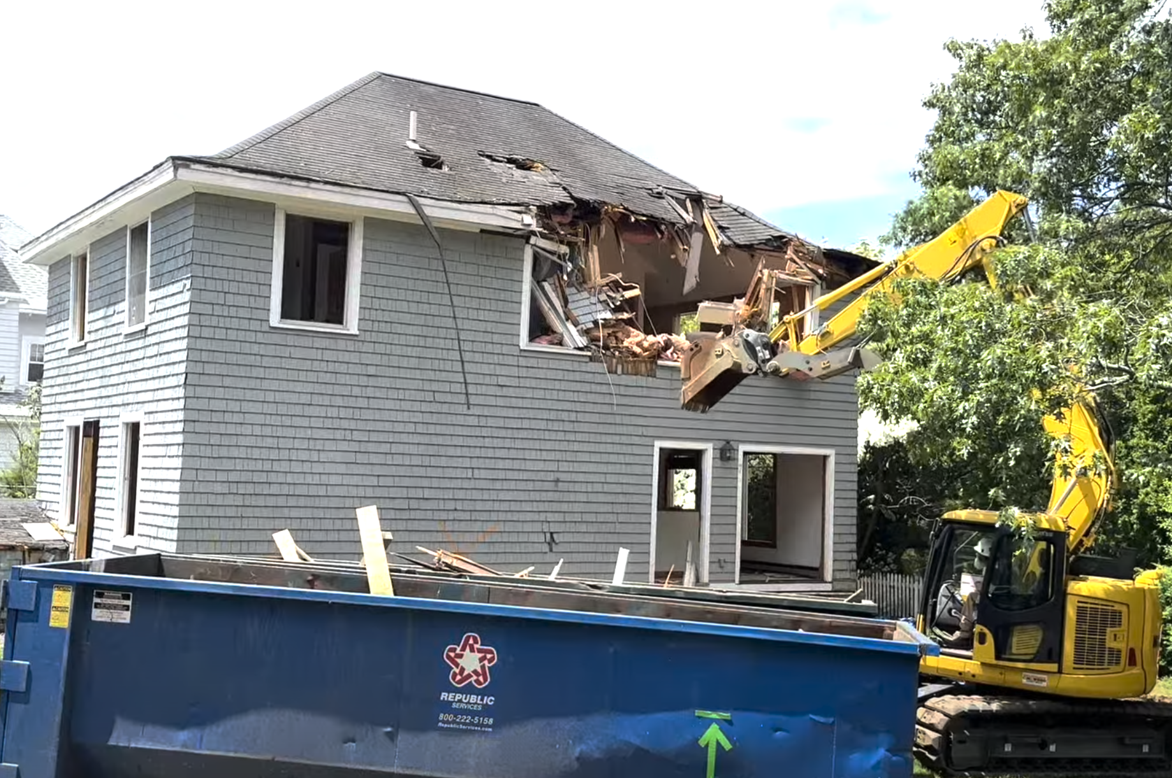
Figure 3: I took over operation of the excavator once demolition of the structure commenced.
(My son is out of frame on dust mitigation.)
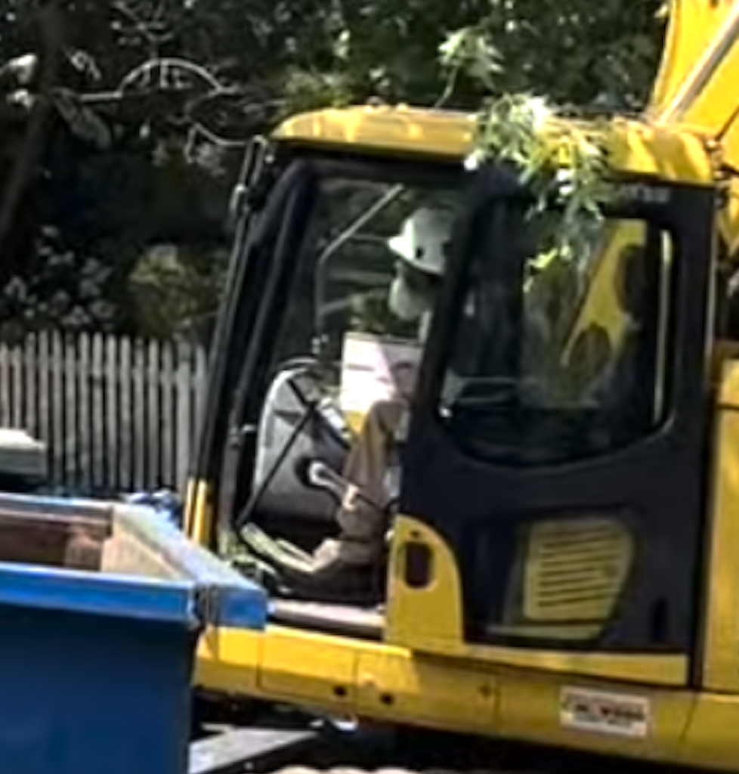
Figure 4: Close-up cropped from Figure 3.
Note identifying beard and white hard hat.

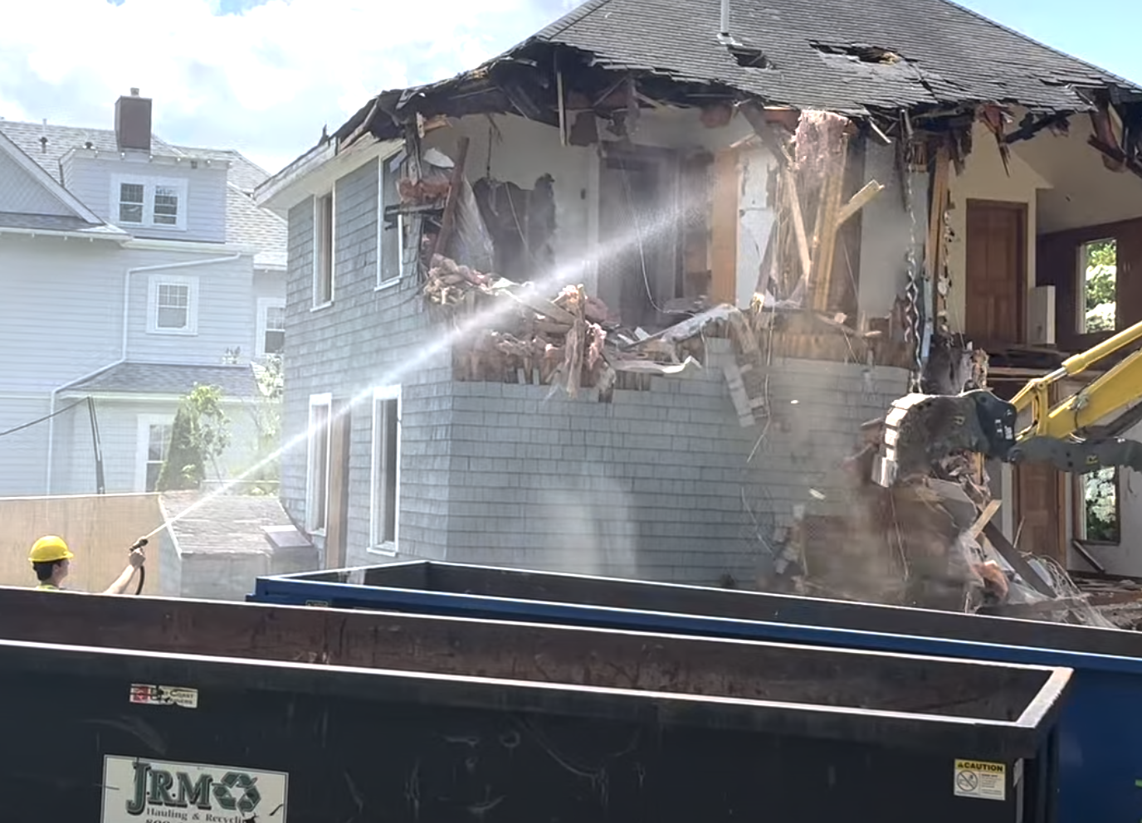
Figure 5: My son managed dust while I operated the excavator throughout the demolition.


